SUNFORGE DIGITAL
Sales Playbook v1.0

Mission
Help local businesses identify where they're losing customers and show them practical solutions to capture more opportunities through better websites and AI-powered phone systems.

Core Philosophy
Don't sell products. Diagnose business problems.
You're not there to convince them they need a website or AI receptionist. You're there to understand how they acquire customers, where opportunities are slipping through the cracks, and whether you can help.
Think like a consultant.

The Customer Journey
Every customer follows roughly the same path. Your job is to find where this process breaks down.
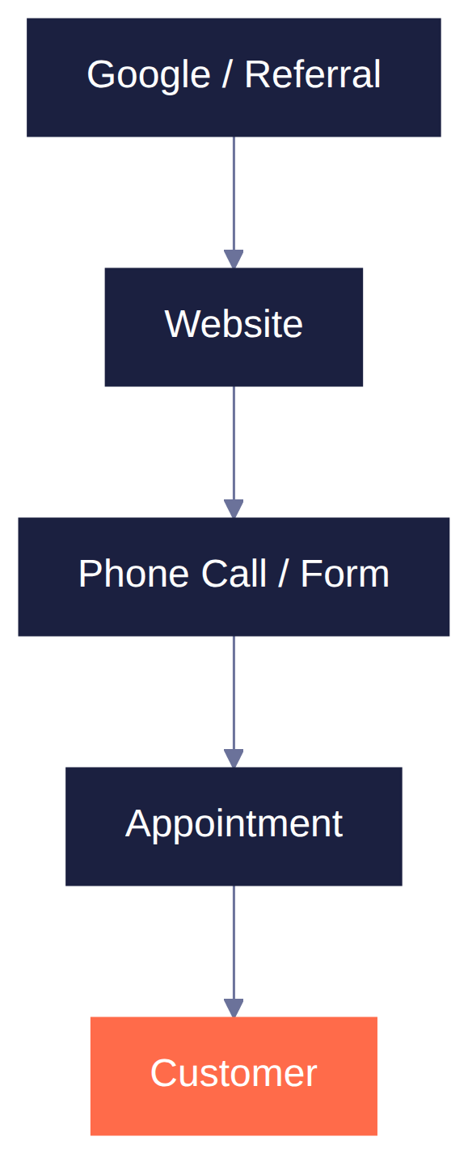

Conversation Flow
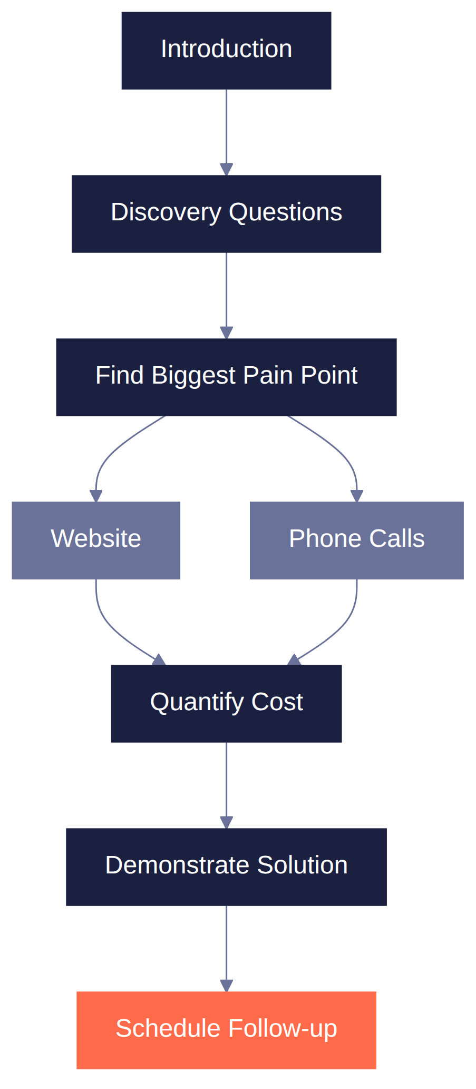

Step 1 — Introduction (30 Seconds)
Hi, I'm Chris with Sunforge Digital. We help local businesses capture more customers through better websites and AI-powered phone systems. I'm talking with businesses around Phoenix to understand how they're currently handling incoming calls and website leads. Do you have about five minutes?

Step 2 — Discovery

Website
Ask naturally.
- Are you happy with your current website?
- Where do most of your new customers come from?
- Do people usually call or fill out a form?
- If you could change one thing about your website, what would it be?
- Do you know roughly how much traffic your website gets?

Phone Handling
This is where the AI conversation usually begins.
- Who normally answers incoming calls?
- What happens if they're already helping another customer?
- What happens after hours?
- During your busy season, does answering every call become difficult?
Then ask the key question:
Do you have a sense of how many calls go unanswered in a typical day or week?
If they don't know:
Even a rough estimate... one or two a day? A few per week? More during busy season?
Then:
When someone doesn't get an answer, what do you think they usually do?
Most owners answer: "They probably call someone else."
Don't interrupt. Let them say it.

Time
- What questions does your team answer over and over every day?
- If your office staff had one extra hour every day, where would you rather they spend it?

Business
- What's an average job worth?
- What's your biggest challenge right now?
- If you could improve one part of your customer experience tomorrow, what would it be?

Step 3 — Identify the Opportunity
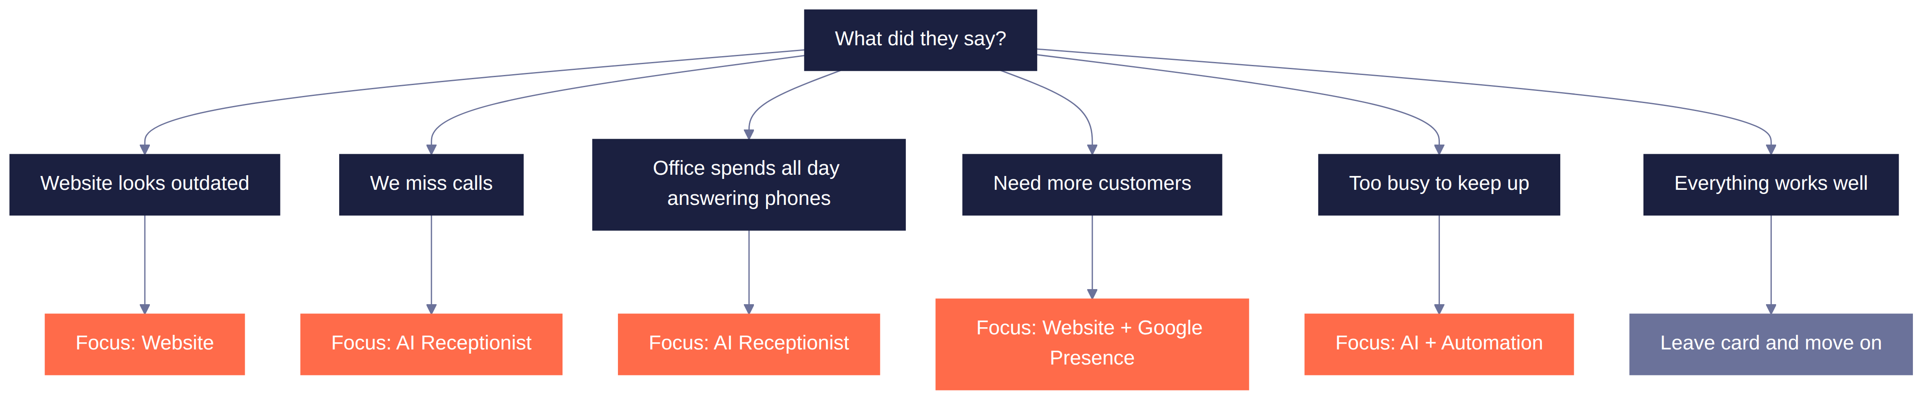
Never force a solution.

Step 4 — Quantify the Cost
This is where you become a consultant.

Phone Example
Owner: "We probably miss five calls a week."
You: "What's an average job, order, or booking worth for you?"
Owner: "About $400."
You: "If even 30% of those missed calls would have become customers..."
Missed calls/week | Conversion rate | = Lost customers/week
5 | × 30% | = 1.5

Lost customers/week | Ticket value | ≈ Lost revenue
1.5 | × $400 | ≈ $600/week (≈ $2,600/month)

Would recovering even part of that make a meaningful difference?
Notice what you didn't do. You didn't sell AI. You discussed business.

Website Example
If your website generated five additional jobs every month... would that move the needle for your business?
If yes — now websites become an investment instead of an expense.

Step 5 — Show, Don't Tell
Never explain first.
Rather than trying to explain it... can I show you what it actually sounds like?
Run the demo. Don't talk during it.
When it's over, ask one question:
What stood out to you?

Step 6 — Close
Don't ask: "Would you like to buy?"
Ask:
Based on what we've talked about, I think there are a couple opportunities worth exploring. I'd love to build a version specifically around your business so you can hear exactly how it would work. Would you be open to another meeting next week?

If They Ask Cost on the Spot
The close above assumes a follow-up meeting, but plenty of owners will ask "so what does this cost" right there in the first conversation. Have this ready — never open with a range, name a number confidently.
"There's a one-time setup fee around $[X] to build it out for your business specifically, and then it's a flat monthly rate after that — no separate software bill, no per-call charges, I handle all of it on my end."
Business type | Build fee | Combined monthly (site + receptionist)
Simple restaurant / home-services | $1,500–2,500 | $450–650/mo
Club / high-volume bar | $3,000–6,000 | $1,075–1,550/mo

If they only want the receptionist, no site:
This costs more per month standalone than the bundled add-on — there's no site revenue offsetting your platform cost, and the knowledge base has to be built from scratch instead of reused site content.
Item | Price
One-time setup fee | $300–500
Monthly — typical volume | $250–350/mo
Monthly — high volume / late hours | $350–450/mo

If they push back on the standalone price:
"It's actually a better deal if we bundle it with a site build — want me to put together what that'd look like together?"
Offer the bundle instead of discounting the standalone monthly number.
If asked about contract length:
"Month-to-month — no long-term lock-in."
If asked "could I just do this myself":
"Technically there's a version of this you could set up yourself, but what you're actually paying for is not having to learn the system, write all the content, or notice and fix it if something's off — same as your website, I handle it so you don't have to think about it."
Full cost breakdown, platform tiers, and margin math live in the Pricing Reference doc — this is just what to say out loud.

If the Owner Isn't There
- Introduce yourself to whoever is available.
- Ask when the owner or manager is usually in.
- Leave a business card.
Write on the back:
AI Receptionist Demo — Call: (###)
Pretend you're one of your customers. Keep it simple.

Objections
"We're too small."
That's actually where these tools can help the most. When you don't have a large staff, every missed call matters.
"We're happy with our website."
That's great. Out of curiosity, do you feel it's bringing you as many customers as it could?
"We already have someone answering the phones."
Perfect. My goal isn't to replace them—it's to make sure no opportunity slips through when they're busy or it's after hours.
"We're too busy."
That's exactly why I stopped by. Sometimes being busy makes it hard to see where a few small improvements could save a lot of time.
"What about SEO?"
That's already built into every site — structured menu data, FAQ content written the way people actually search, and I check that you show up not just on Google but when someone asks ChatGPT or Perplexity for a recommendation too. It's not an add-on, it's just how I build.

The Mindset
At the end of every conversation, ask yourself:
- Did I learn something about their business?
- Did I uncover a real problem?
- Did we talk about what that problem might be costing them?
- Did I show a relevant solution?
- Did we agree on a next step?
If the answer is yes — even if they didn't buy — you had a successful conversation.

Version 1.0 Success Metric
Don't judge this playbook by whether you make a sale in the first week. Judge it by what you learn after talking to 15 business owners.
Track things like:
- Which questions sparked the best conversations?
- What pain points came up most often?
- Which objections repeated?
- How did owners react to the AI demo?
- Did anyone ask for pricing or a follow-up?
That feedback will tell us what to improve. The goal of this first version isn't perfection — it's to create a repeatable process that gets you into real conversations and lets the market shape version 2.0.

